|  |  |  |  |  |
| --- | --- | --- | --- | --- |
| **SL** | **Server Names** | **Specifications** | **Quantity** | **Remarks** |
| **Server Configuration (*Basic)*** | | | | |
| 1 | Application Server | **Processor**:  Intel(R) Xeon(R) 2.70GHz  (2 Processor)  **RAM**: 32 GB  **HDD**: 500 GB or  **SDD**: 500 GB | 1 | Microsoft Windows Server 2016 |
| 2 | Database Server  SQL Server Database | **Processor**:  Intel(R) Xeon(R) 2.70GHz  (2 Processor)  **RAM**: 32 GB  **HDD**: 1 TB or **SDD**: 1 TB | 1 | Microsoft Windows Server 2022 |
| **Server Configuration (*Web Farm*)** | | | | |
| 1 | Application Server | **Processor**:  Intel(R) Xeon(R) 2.70GHz  (2 Processor)  **RAM**: 32 GB  **HDD**: 500 GB or **SDD**: 500 GB | 2 or more | Microsoft Windows Server 2016 |
| 2 | Database Server  (SQL Server Database) | **Processor**:  Intel(R) Xeon(R) 2.70GHz (2 Processor)  **RAM**: 32 GB  **HDD**: 1 TB or **SDD**: 1 TB | 1 | Microsoft Windows Server 2022 |
| **Server Configuration (*Always On High Availability*)** | | | | |
| 1 | Application Server | **Processor**:  Intel(R) Xeon(R) 2.70GHz  **RAM**: 32 GB  **HDD**: 500 GB or **SDD**: 500 GB | 1 | Microsoft Windows Server 2016 |
| 2 | Database Server  (SQL Server Database) | **Processor**:  Intel(R) Xeon(R) 2.70GHz  (2 Processor)  **RAM**: 32 GB  **HDD**: 1 TB or **SDD**: 1 TB | 2 or more | Microsoft Windows Server 2022 |
| **Server Configuration (*Web Farm and Always On High Availability*)** | | | | |
| 1 | Application Server | **Processor**:  Intel(R) Xeon(R) 2.70GHz  **RAM**: 32 GB  **HDD**: 500 GB or **SDD**: 500 GB | 2 or more | Microsoft Windows Server 2016 |
| 2 | Database Server  (SQL Server Database) | **Processor**:  Intel(R) Xeon(R) 2.70GHz  (2 Processor)  **RAM**: 32 GB  **HDD**: 1 TB or **SDD**: 1 TB | 2 or more | Microsoft Windows Server 2022 |

1. **Server Configuration (*Basic)***

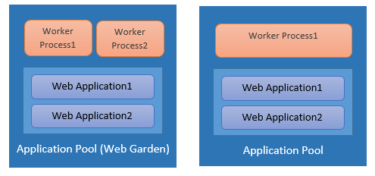

1. **Server Configuration (*Web Farm*)**

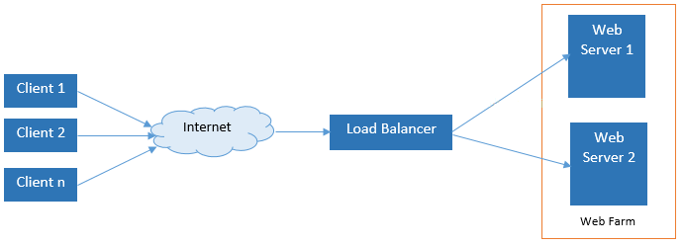

1. **Server Configuration (*Always On High Availability*)**

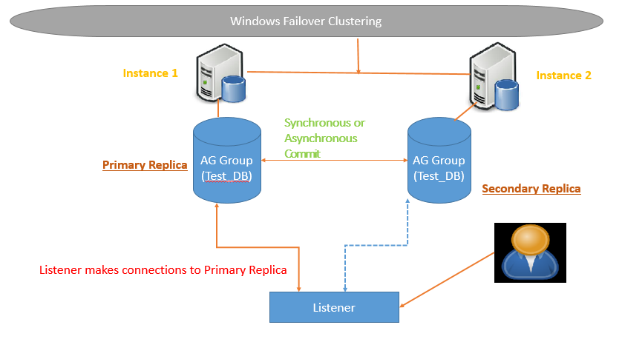

1. **Server Configuration (*Web Farm and Always On High Availability*)**



*Fig: Web Farm*



*Fig: Always On High Availability*